Write your title here (This is style Poster title)

Main Author¹ (main.author@email), Second Author², Third Author³, Fourth Author⁴ and so on in a form Full first name Family name (This is style Authors)
¹ Organisation and address, country, ² Organisation and address, country, ³ Organisation and address, country, ⁴ Organisation and address, country

Abstract (This is style Normal: Calibri 12 pt and bold)

Write here your text. This is style Normal: Calibri 12 pt.

This template is used both for EuroWorkS2014 abstract and proceeding text. Send your abstract as Word format (doc or docx) to Ekaterina.petruneva@mtt.fi by 31st of August and proceeding text by 16th of October.

Key words

Introduction

Write here your text. This is style Normal: Calibri 12 pt.
Titles of your proceeding text are not needed to be the ones suggested here. You are welcome to change them more suitable for you.

Materials and methods

Write here your text. This is style Normal: Calibri 12 pt.

Results

Write here your text. This is style Normal: Calibri 12 pt.

Bring pictures and graphics to the document in jpg or similar steady form. If you want to put them for example in a row as shown below, they stay nicest in their position in the text if you place them inside the table. Here an example:

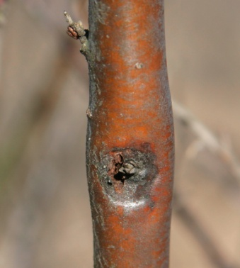 | 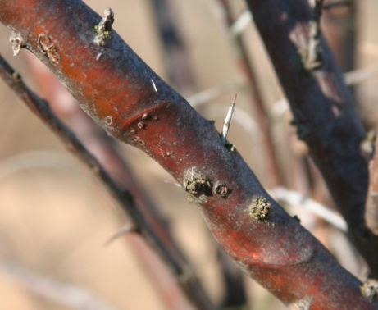
Pictures 1, 2 & 3 from the left. Picture 1 is showing a small stem canker lesion around the bud. In picture 2 lesion has already girdled the stem. In picture 3 berries of sea buckthorn have got spots that may be caused by the same fungus than the stem canker.

Discussion

Write here your text. This is style Normal: Calibri 12 pt.

Acknowledgements

Write here your text. This is style Normal: Calibri 12 pt.

References

Write here your text. This is style Normal: Calibri 12 pt.

